**AN APPROACH FOR CLASSIFYING SENTIMENTS IN ONLINE PRODUCT REVIEWS**

*1Bitla Sariu , 2Devunuri Akhil,3Rangaraju Chaithanya, 4Mr B.Naresh*

# *1,2,3bachelor Degree, Cse,* *Jayamukhi Institute Of Technological Sciences Narsampet, Warangal.*

*4Mr B.Naresh, Associate Professor, bachelor Degree, Cse, Jayamukhi Institute Of Technological Sciences Narsampet, Warangal.*

**ABSTRACT:**

Sentiment analysis, commonly referred to as opinion mining, reveals the attitudes and feelings of consumers towards certain goods or services. The sentiment polarity classification, which identifies whether a review is favourable, negative, or neutral, is the fundamental issue with sentiment analysis. However, there are still some study gaps. For example, some studies only contain the three sentiment classes of positive, neutral, and negative; none of them took into account more than three classes. Sentiment polarity characteristics were taken into account on an individual basis, but none were taken into account on an individually and combined basis.

iii) No prior approach took into account the verb, adverb, adjective, and their combinations, as well as five emotion classes and three sentiment polarity traits. In this study, we provide a method for categorising online evaluations of Instant Videos based on their emotion. Our study makes use of a large data collection that includes 500,000 internet reviews.

Strongly Positive, Unfavourable Neutral, positive, or Strongly Good are the five categories. In the review-level categorization process, we additionally take into account the three polarity characteristics verb, adverb, and adjective as well as their pairings with various senses. Our trials for review-level classification produced encouraging results since the accuracy of our findings was 81 percent, which is 3 percent greater than the accuracy of several prior methodologies, which was 78 percent on average.

**INTRODUCTION:**

In the past ten years, business has begun to understand the value of user opinion. Since then, consumer reviews of items are gathered through social media platforms and other websites. The term sentiment analysis or opinion mining refers to this phenomenon. By examining the text, opinion mining identifies, extracts, and understands the attitude or opinion of the user. Typically, this method includes sentiment analysis using artificial intelligence, mathematical modelling, and processing of natural language. The terms review mining, emotive analysis, opinion extraction, and subjective analysis are just a few that are often employed [1]. Smith [2] outlined the definition of sentiment analysis as:

The computer analysis of documents to ascertain sentiment is known as sentiment analysis.

emotions that are expressed at a finer level. Sentiment analysis is the study of how individuals feel about various things, such as texts, people, products, etc. Whether we like it or not, their thoughts reflect how they feel about a certain thing. It is a technique of computationally recognising and classifying the reviews' opinions to determine whether they are favourable, unfavourable, or neutral. The internet today offers individuals a variety of sites on which to express their textual opinions about various things.

Since consumers are the greatest evaluators of items, many huge organisations may enhance profits by paying attention to what people are saying about them. Large organisations can improve their goods based on client feedback to better meet their demands. So it becomes the most significant difficulty for NLP (natural language processing) in the modern era due to its extreme necessity. Sentiment analysis techniques are therefore often utilised for the extraction of subjective data in source material such as critiques of products.

**RELETED DATA:**

Three broad categories may be used to group the various sentiment analysis tools. For example, (a) knowledge-based approaches, (b) statistically based procedures, and (c) hybrid methods, which combine the first two types of approaches.

Lexical knowledge-based approaches typically concentrate on univocal words like happy, sad, or afraid, whereas statistical approaches use automated techniques to assess sentiments based on machine learning analysis, and hybrid approaches combine both techniques to examine the outcomes of reviews that are not explicitly stated but do have some connection to the product. Some research are closely related to our strategy, such as Fang and Zhan's [9] proposal of a method for classifying polarity based on parts of speech (POS).

Hu and Liu [10] used an alternative technique and supplied a list of various words (both positive and negative terms).The suggested list of terms included 4783 negative words and 2006 positive words. These phrases are based on internet reviews, which were utilised to gather the research's subjective data. Additionally, Pang and Lee [11] recommended how to eliminate objective phrases by extracting the subjective ones since we should primarily focus on subjective contents and avoid wasting time on useless stuff.

In a different method suggested by Gann and Day [12], the authors employed a token-based approach on Twitter data, assigning emotive ratings to each token in order to determine if a certain view is good, negative, or neutral. Other methods are also beneficial. One such method is topic modelling [13], where the author suggested a method of automatically finding the characteristics or facets of a product. Regarding the sentiment analysis of microblogging services like twitter, numerous methodologies have been put out in the scientific community.

Chen and Das [14], offered a method for collecting sentiment from stock message boards, and the authors speculated that market activity may have an impact on investors in the middle and lower ranges of the distribution. Subject-centric sentiment analysis is the basis of another study by Nasukawa and Yi [15]. Instead of identifying or computing the sentiment for entire publications, the suggested approach creates a system that determines the polarity scores (i.e., negative and positive sentiment scores) connected with a particular subject. Using datasets from several domains, including news and other web sites, the suggested strategies have been assessed. Depending on the various kinds of datasets utilised in the evaluation, the suggested approach yields an overall accuracy score of 75 to 76 percent. Techniques for natural language processing have been used to do the sentiment analysis. Traditionally, there are three basic ways that may be used to do sentiment analysis: a machine learning approach, b a lexicon-based approach, and c a hybrid approach [16].

R. Xia et al. [17] created a hybrid sentiment analysis method. The suggested method for sentiment analysis combines methodologies based on lexicons and machine learning. POS are chosen from the lexicon together along with the associated and word-related variables, and then neural network filters are used.

On the dataset, tests were conducted utilising various combinations, including fixed weighted, meta classifiers, and ensemble combination techniques, in order to improve the classification results. Gamallo et al. offered a few Naive Bayes variants. [18] used multiple iterations of the Naive Bayes classifier to categorise opinions into distinct groups. In the experiment, features including Valence Shifters, Polarity Lexicon, Lemmas, and Multiword were employed.

For analysis of sentiment, Nandi and Agrawal [19] suggested a layered hybrid technique. The suggested method consists of two levels; the first layer is lexicon-based, and the second layer is machine learning-based.

. To categorise the sentiment of opinions into distinct classifications, such as positive, negative, and neutral classes, machine learning classifiers are utilised.An innovative hybrid technique to sentiment analysis was introduced by Rajganesh et al. [20]. The method is a sentiment analysis-based feedback-based recommendation system.

**EXISTING SYSTEM:**

The results show that outperforms the existing methods and among four categories of features;

including review-behavioural, use behavioural, review linguistic, user linguistic, the first type of features performs better than the other categories.

Despite this great deal of efforts, many aspects have been missed or remained unsolved. One

of them is a classifier that can calculate feature weights that show each feature’s level of importance in determining spam reviews. The general concept of our proposed framework is to model a given review dataset as a Heterogeneous Information Network (HIN) and to map the problem of spam detection into a HIN classification problem. In particular, we model review dataset as a HIN in which reviews are connected through different node types. The general concept of our proposed framework is to model a given review dataset as a Heterogeneous Information Network and to map the problem of spam detection into a HIN classification problem. In particular, we model review dataset as in which reviews are connected through different node types. **A weighting algorithm** is then employed to calculate each feature’s importance. These weights are utilized to calculate the final labels for reviews using both unsupervised and supervised approaches.

**PROPOSED SYSTEM:**

In this proposed can find features importance even without ground truth, and only by relying on meta path definition and based on values calculated for each review. Improves the accuracy compared to the state of- the art in terms of time complexity, which highly depends to the number of features used to identify a spam review; hence, using features with more weights will resulted in detecting fake reviews easier with less time complexity.

A new **Content Based Algorithm** for spam features is proposed to determine the relative importance of each feature and shows how effective each of features are in identifying spams from normal reviews.

**RESULT:**

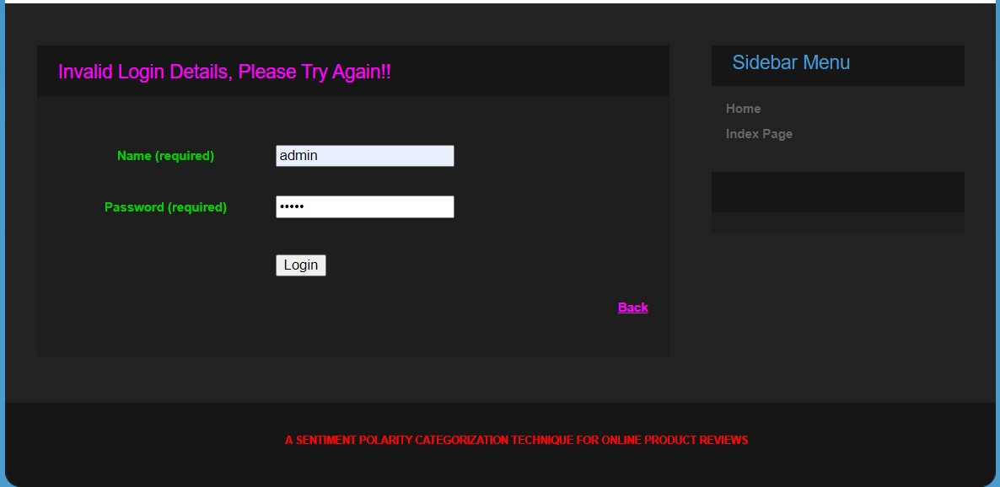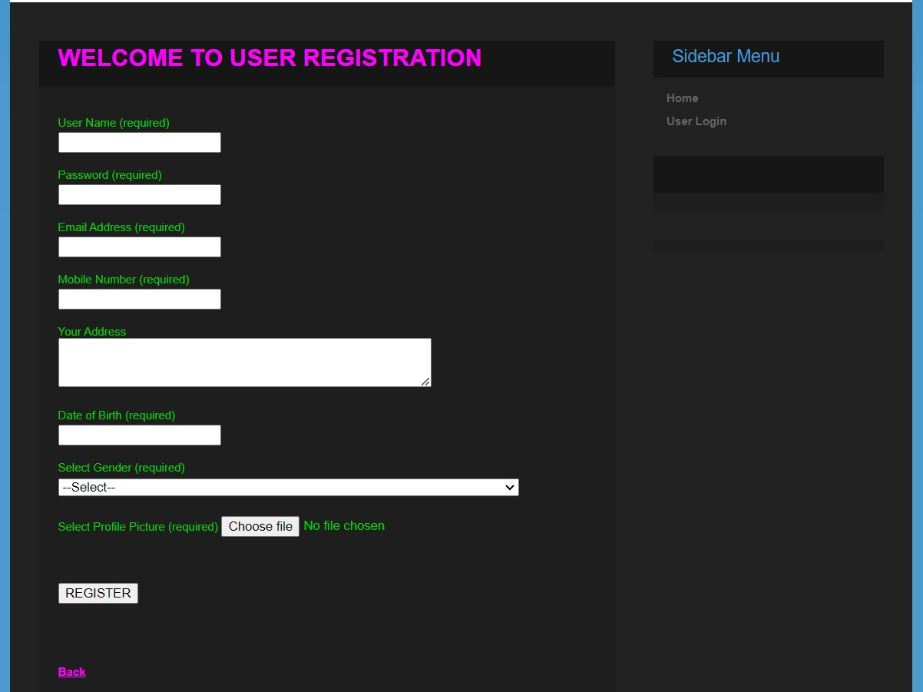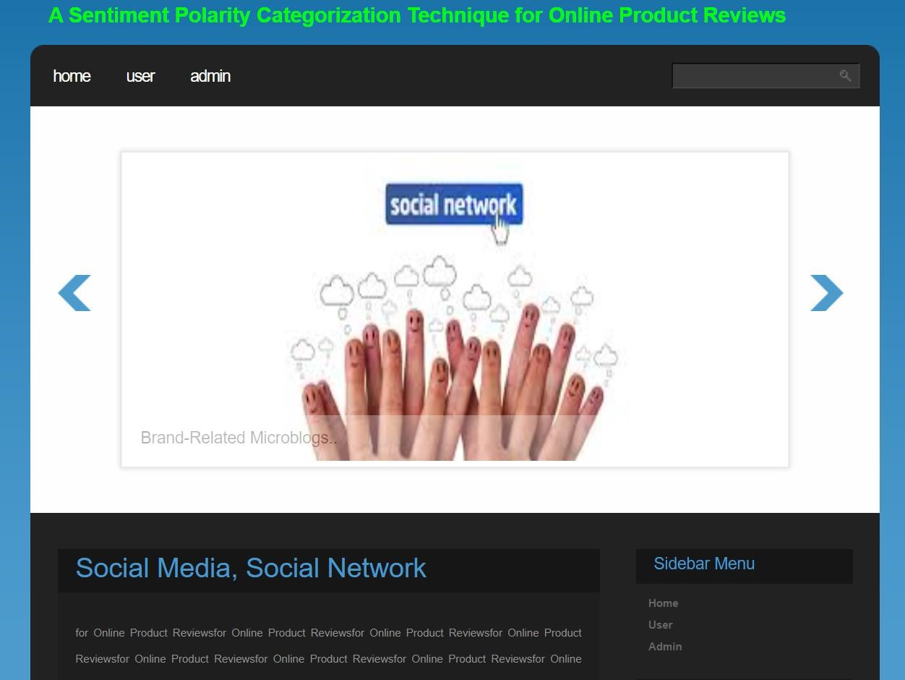

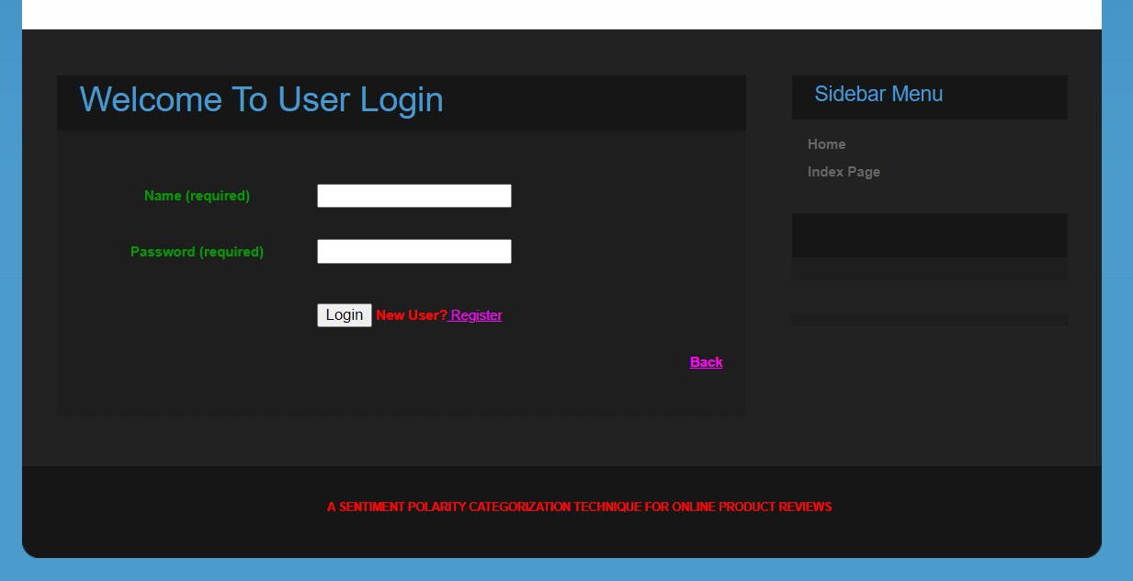

**CONCLUTION:**

This research contains limitations, much as other research.

Although automated sentiment analysis is useful for analysing large amounts of textual data, it still has several limitations. The software that we employed for this study project has the capacity to handle various kinds of textual data. But it has the limitation of not processing other styles, such sarcasm. On the other hand, there is still room for advancement in the domain of natural language processing. The information in internet reviews can be better understood in the future through study that makes use of more sophisticated technologies. Future studies may examine the impact of various customer review factors on product quality and marketing tactics in the area of data mining.

**REFERENCES:**

[1] B. Liu, ‘‘Sentiment analysis and opinion mining,’’ Synth. Lectures Hum. Lang. Technol., vol. 5, no. 1, pp. 1–167, 2012.

[2] P. Smith, ‘‘Sentiment analysis: Beyond polarity thesis proposal,’’ School Comput. Sci. Univ. Birmingham, Birmingham, U.K., Tech. Rep., Oct. 2011, pp. 1–42.

[3] R. S. Jagdale, V. S. Shirsat, and S. N. Deshmukh, ‘‘Sentiment analysis on product reviews using machine learning techniques,’’ in Cognitive Informatics and Soft Computing. Singapore: Springer, 2018, pp. 639–647, doi: 10.1007/978-981-13-0617-4_61.

[4] M. Devika, C. Sunitha, and A. Ganesh, ‘‘Sentiment analysis: A comparative study on different approaches,’’ Procedia Comput. Sci., vol. 87, pp. 44–49, Jan. 2016.

[5] K. Schouten and F. Frasincar, ‘‘Survey on aspect–level sentiment analysis,’’ IEEE Trans. Knowl. Data Eng., vol. 28, no. 3, pp. 813–830, Mar. 2016.

[6] R. Arulmurugan, K. R. Sabarmathi, and H. Anandakumar, ‘‘Classification of sentence level sentiment analysis using cloud machine learning techniques,’’ Cluster Comput, vol. 22, no. S1, pp. 1199–1209, Jan. 2019, doi: 10.1007/s10586-017-1200-1.

[7] P. Burnap, R. Gibson, L. Sloan, R. Southern, and M. Williams, ‘‘140 characters to victory?: Using Twitter to predict the UK 2015 general election,’’ Electoral Stud., vol. 41, pp. 230–233, Mar. 2016, doi: 10.1016/j.electstud.2015.11.017.

[8] A. S. Manek, P. D. Shenoy, M. C. Mohan, and V. K. R, ‘‘Aspect term extraction for sentiment analysis in large movie reviews using Gini Index feature selection method and SVM classifier,’’ World Wide Web, vol. 20, no. 2, pp. 135–154, Mar. 2017, doi: 10.1007/s11280-015-0381-x.

[9] X. Fang and J. Zhan, ‘‘Sentiment analysis using product review data,’’ J. Big Data, vol. 2, no. 1, p. 5, Dec. 2015, doi: 10.1186/s40537-015-0015-2.

[10] M. Hu and B. Liu, ‘‘Mining and summarizing customer reviews,’’ in Proc. ACM SIGKDD Int. Conf. Knowl. Discovery Data Mining (KDD), 2004.

[11] B. Pang and L. Lee, ‘‘Opinion mining and sentiment analysis,’’ Found. Trends Inf. Retr., vol. 1, nos. 1–2, pp. 1–135, 2008, doi: 10.1561/1500000011.

[12] W.-J. K. Gann, J. Day, and S. Zhou, ‘‘Twitter analytics for insider trading fraud detection system,’’ in Proc. 2nd ASE Int. Conf. Big Data, 2014.

[13] Y. Liu, ‘‘Social media tools as a learning resource,’’ J. Educ. Technol. Develop. Exchange, vol. 3, no. 1, pp. 101–114, Mar. 2017.

[14] S. R. Das and M. Y. Chen, ‘‘Yahoo! For Amazon: Sentiment parsing from small talk on the Web,’’ Inst. Oper. Res. Manage. Sci., Catonsville, MD, USA, Tech. Rep., Sep. 2007, vol. 53, no. 9, pp. 1–16.

[15] T. Nasukawa and J. Yi, ‘‘Sentiment analysis: Capturing favorability using natural language processing,’’ in Proc. Int. Conf. Knowl. Capture (K-CAP), 2003, pp. 70–77.

[16] A. Cambero, ‘‘A comparative study of Twitter sentiment analysis methods for live applications,’’ B. Thomas Golisano College Comput. Inf. Sci., Rochester Inst. Technol., Rochester, NY, USA, Tech. Rep. 8, 2016.

[17] R. Xia, C. Zong, and S. Li, ‘‘Ensemble of feature sets and classification algorithms for sentiment classification,’’ Inf. Sci., vol. 181, no. 6, pp. 1138–1152, Mar. 2011, doi: 10.1016/j.ins.2010.11.023.

[18] P. Gamallo and M. Garcia, ‘‘Citius: A naive–Bayes strategy for sentiment analysis on english tweets,’’ in Proc. 8th Int. Workshop Semantic Eval. (SemEval), 2014, pp. 171–175.

[19] V. Nandi and S. Agrawal, ‘‘Political sentiment analysis using hybrid approach,’’ Int. Res. J. Eng. Technol., vol. 3, no. 5, pp. 1621–1627, 2016.

[20] N. Rajganesh, C. Asha, A. T. Keerthana, and K. Suriya, ‘‘A hybrid feedback based book recommendation system using sentiment analysis,’’ Int. J. Sci. Res. Comput. Sci., Eng. Inf. Technol., vol. 3, no. 3, pp. 2456–3307, 2018.

[21] M. Salehan and D. J. Kim, ‘‘Predicting the performance of online consumer reviews: A sentiment mining approach,’’ in Proc. ICIS, 2014.

[22] Y.-H. Hu, K. Chen, and P.-J. Lee, ‘‘The effect of user-controllable filters on the prediction of online hotel reviews,’’ Inf. Manage., vol. 54, no. 6, pp. 728–744, Sep. 2017.